**Week 4 Sample Questions**

**Q1**

**Problem Description**

*A student can register on a number of modules in CIT.*

*Each module can be taken by any number of students.*

*The following details need to be recorded for a student : name, number and email Address.*

*The following details are recorded for a module. Module code, module name , and module description.*

*A Module may be offered a number of times such as semester 1 and semester 2*

*Some modules have never been offered.*

*It a requirement from a billing perspective to keep track of the date a particular student registers for a module.*

*It is also a requirement that a student may need to register for the same module a number of times because they fail. A student wishes to be able to get a list of all students currently taking a particular module.( in case they need to contact them about assigned work).*

**Question**

Develop a Domain module to capture the information specified above and to allow for the requirements outlined to be satisfied.

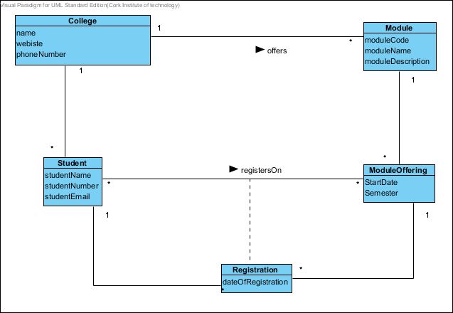

**Abstraction-Occurrence Pattern**

Capture shared attributes of objects that represent an abstract identity or "sameness" and support the creation of new abstractions without writing code.

#### Structure

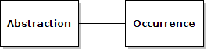

#### Participants

* *Abstraction* - instances of this class represent abstractions: groupings of things that are abstractly the same.
* *Occurrence* - instances of this class represent things that can be grouped into abstractions.

**Examples**

The occurrences can be just about anything. The abstractions often arise in one of the following situations:

* you have multiple copies of the "same" thing: books, video recordings, audio recordings.
* you have multiple schedulings of the "same" event: courses, flights, television shows.

